VPC Challenge
First create three vpc 1,2,3
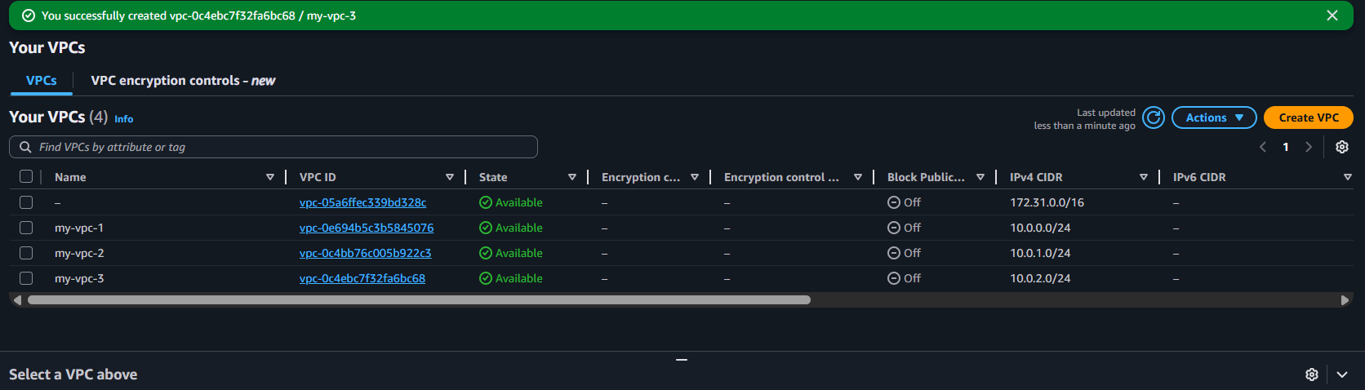

CREATE SUBNETS three subnets1,2,3 attach VPC’s
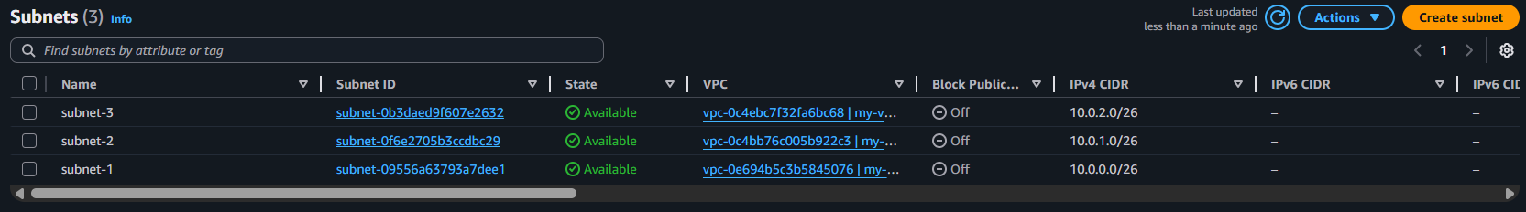

CREATE INTERNET GATEWAYS
For every 1 transit gateway attach vpc
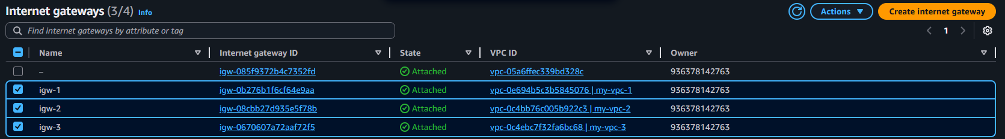
EDIT ROUTE TABLES FOR INTERNET ACCESS
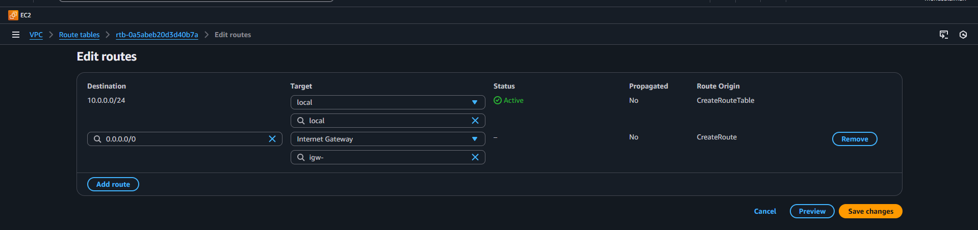
Now we successfully add three internet access

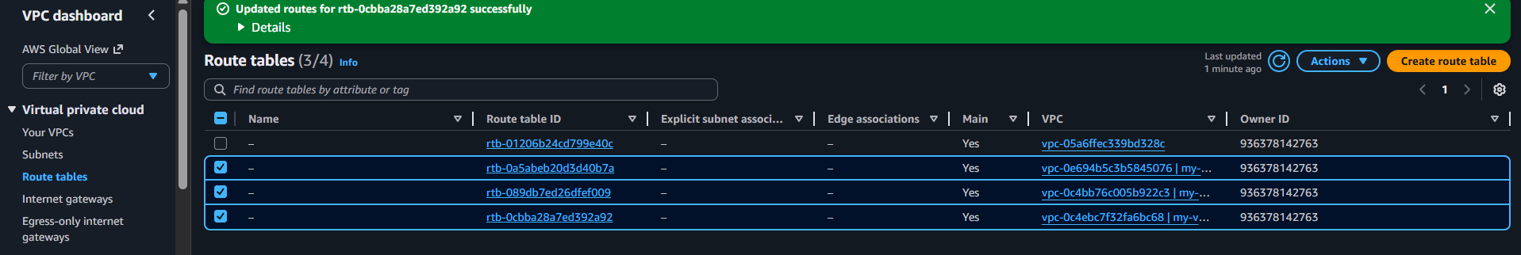
CREATE 3 EC2 INSTANCES
Our first instance
Make sure your auto-assign public ip is enable if disable you cant connect
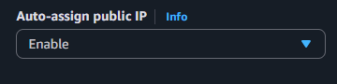
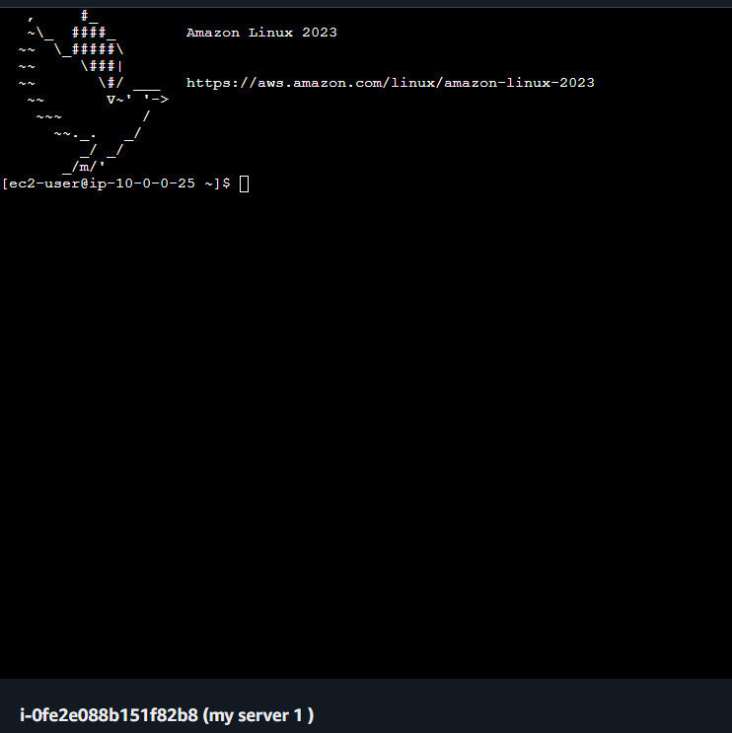

Our next

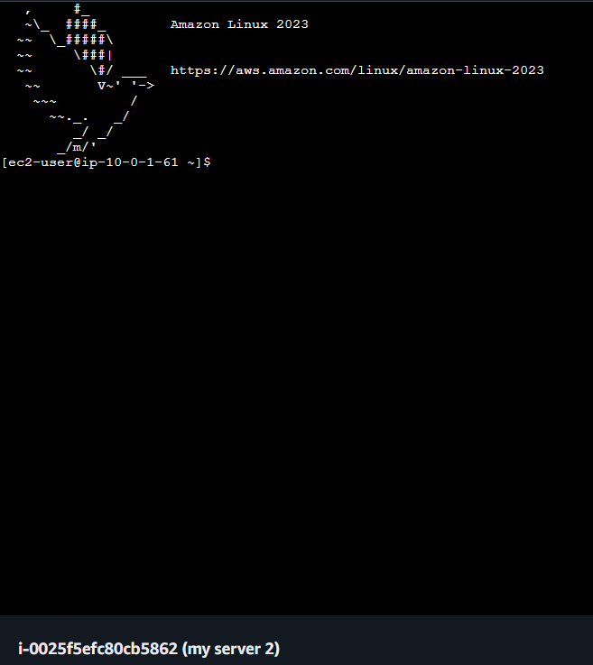
Now add your subnet,vpc according to your configuration that create it
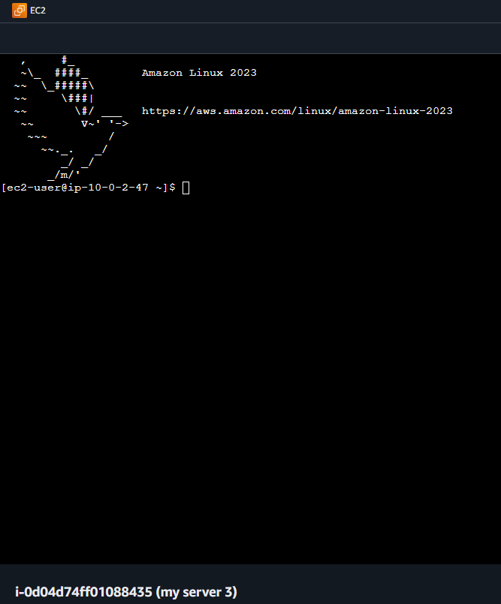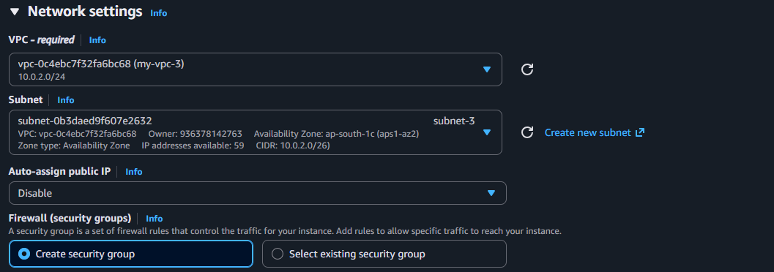

6 CREATE TRANSIT GATEWAY

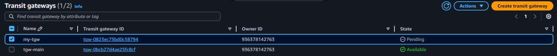
Attach your vpc and subnet 1 2 3
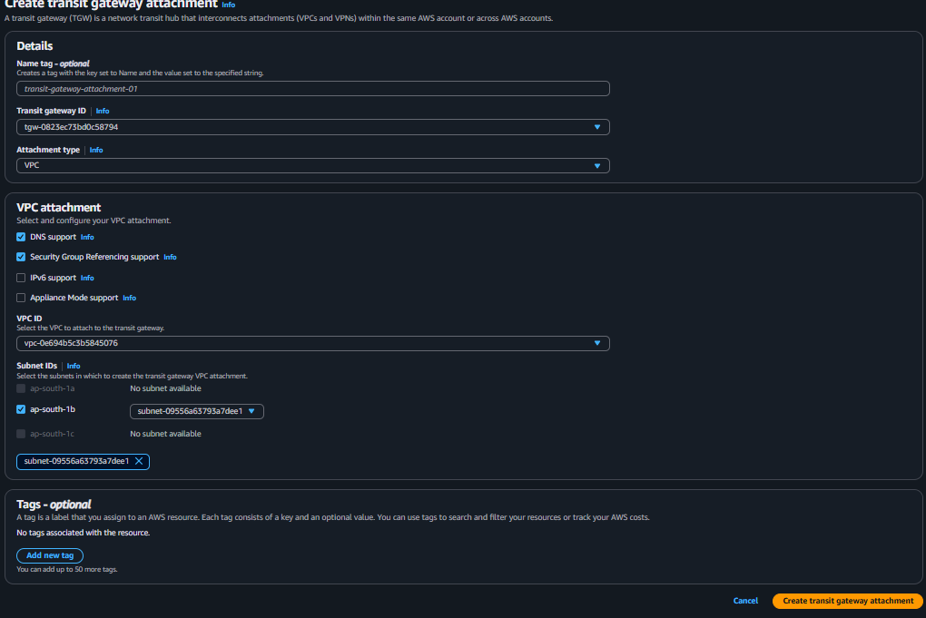
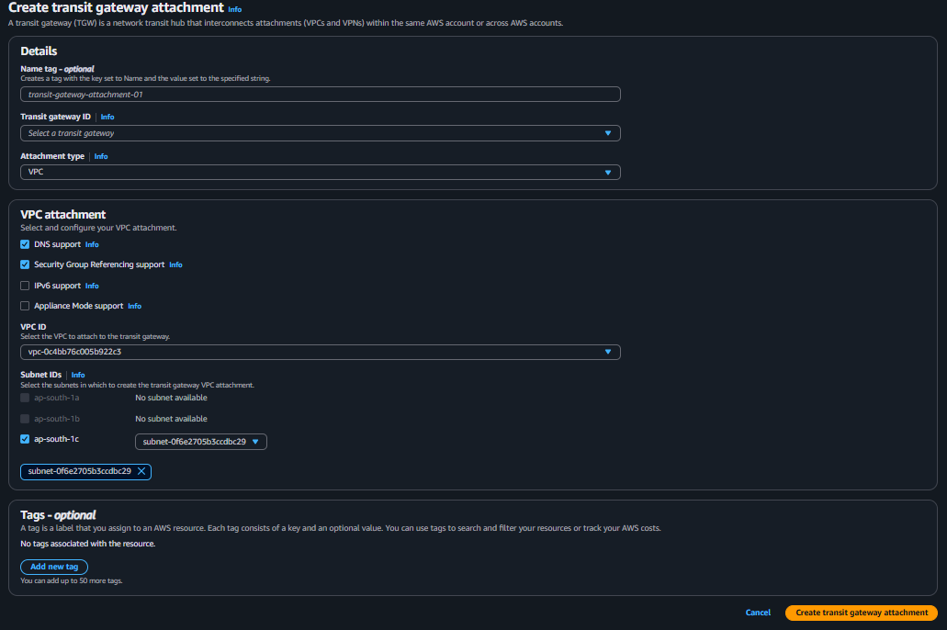
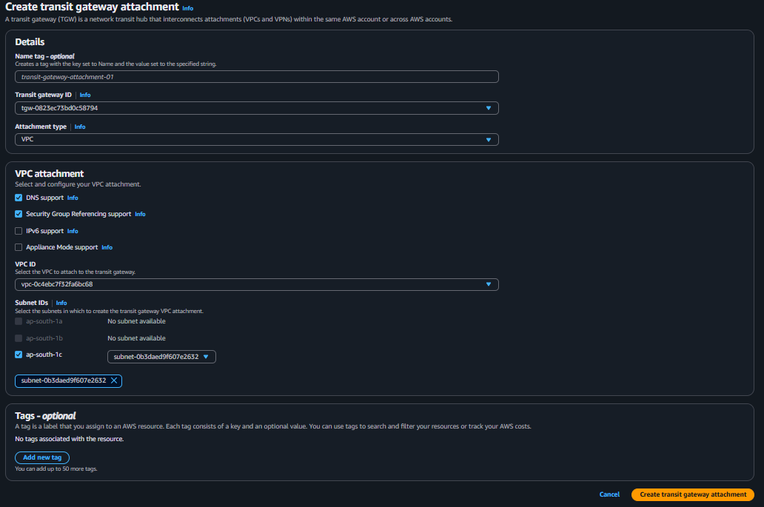

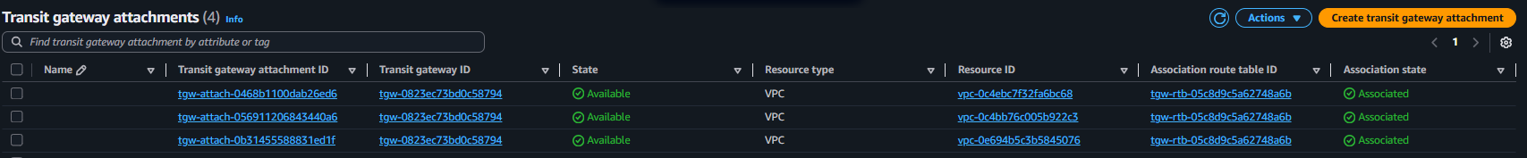

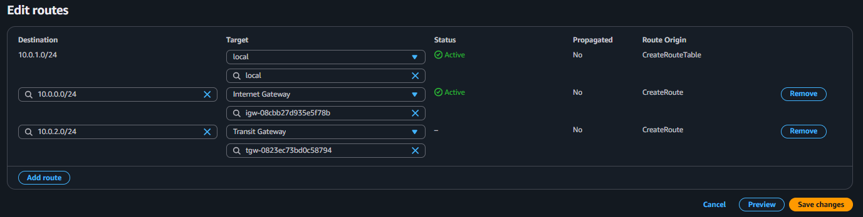
Now we succefully updated our routes

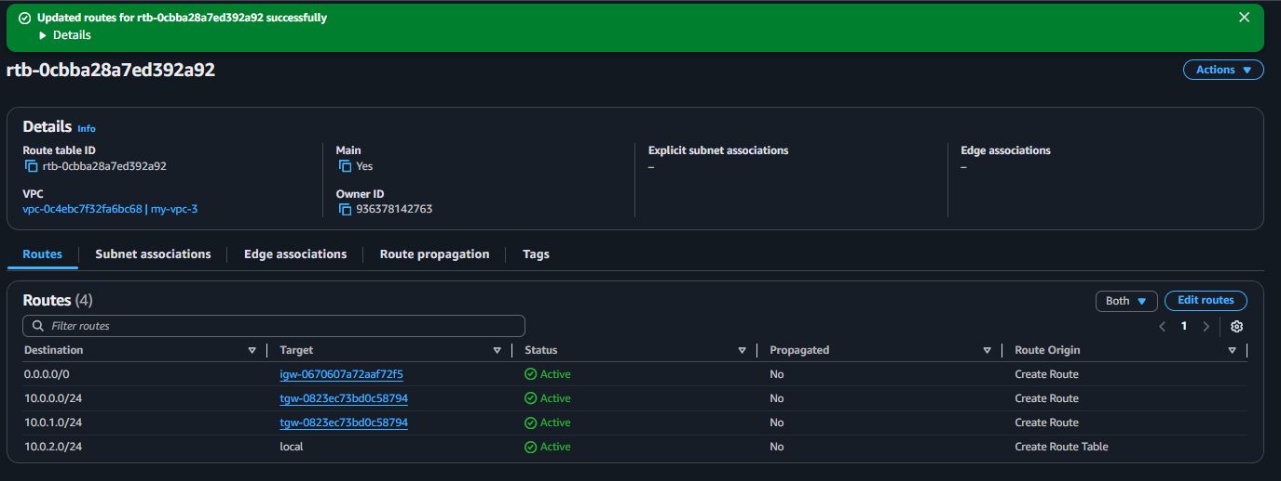

CONFIGURE S3 VPC ENDPOINT
Create S3 bucket name must unique
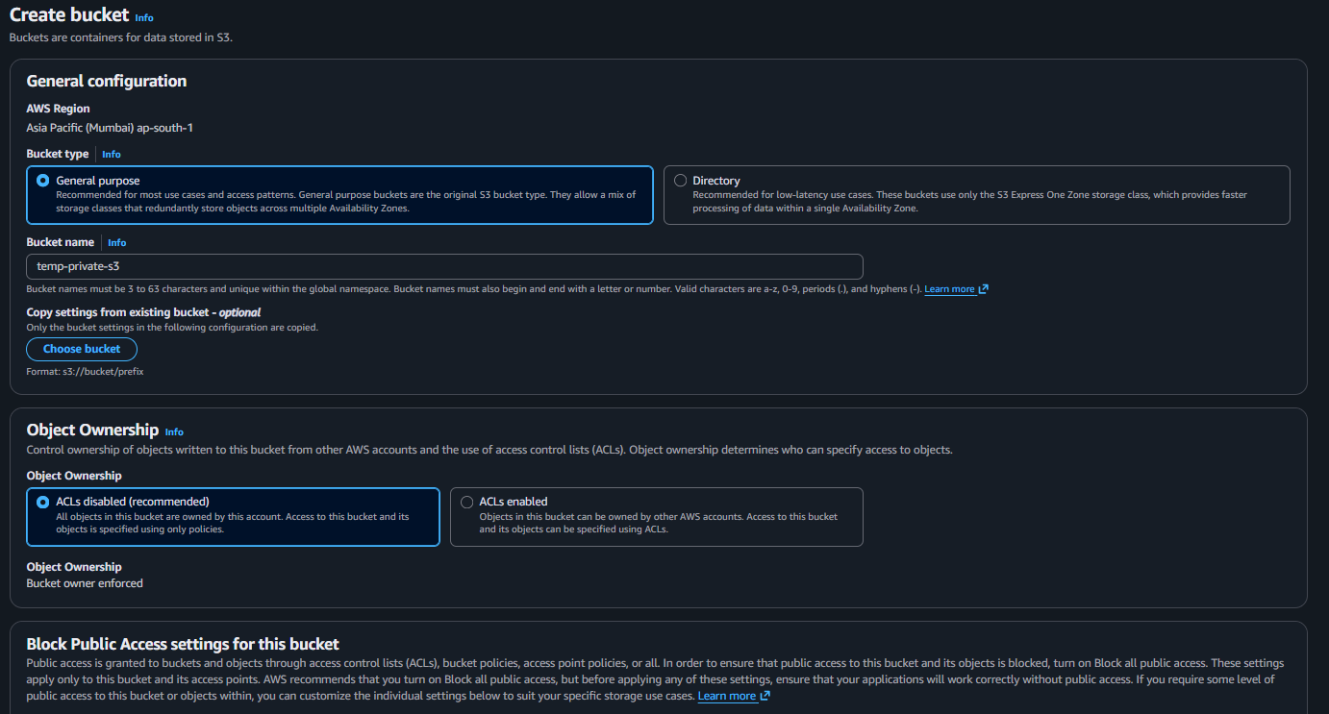
Create IAM Access Key
Ho create access key button
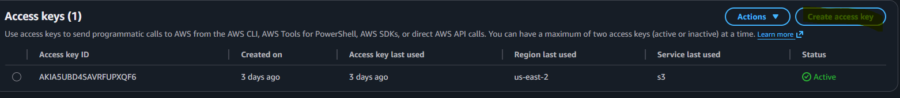

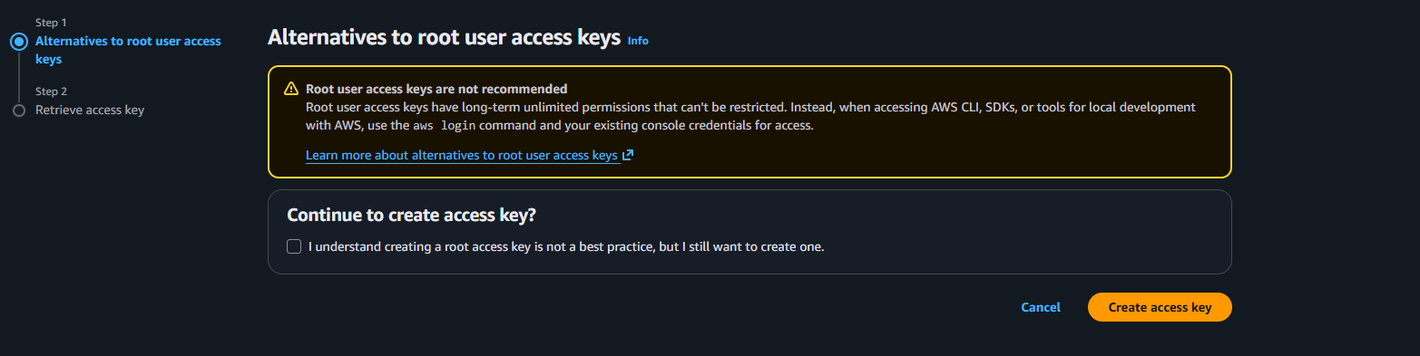

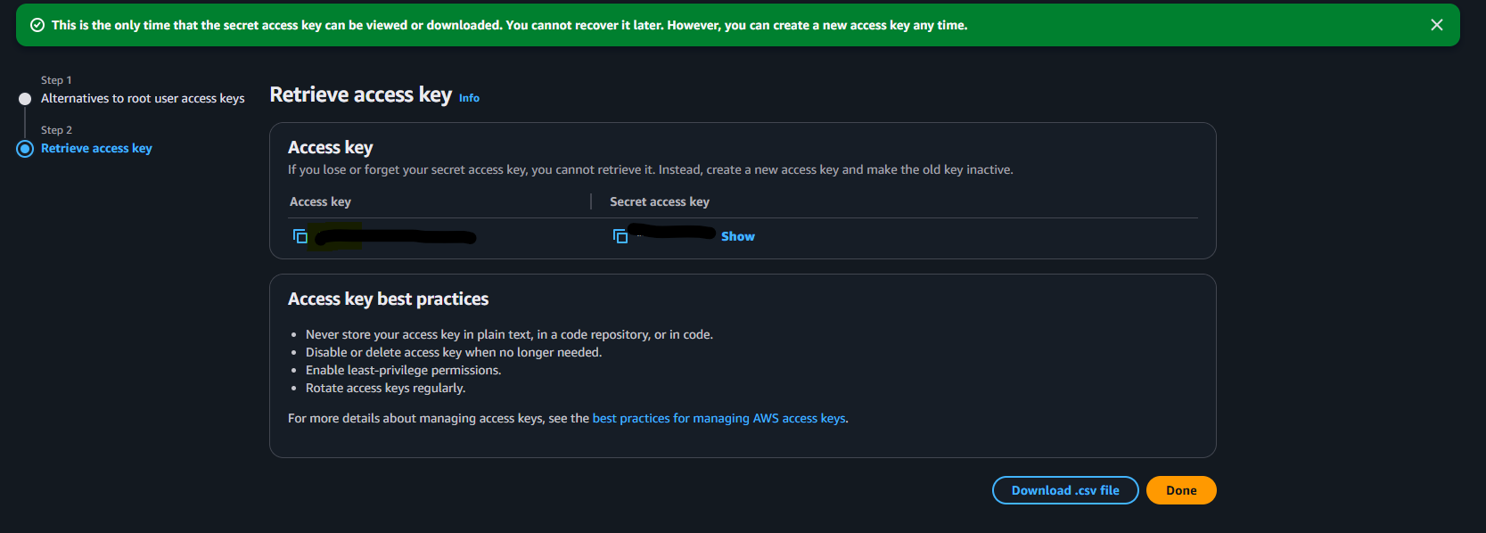

Create VPC Endpoint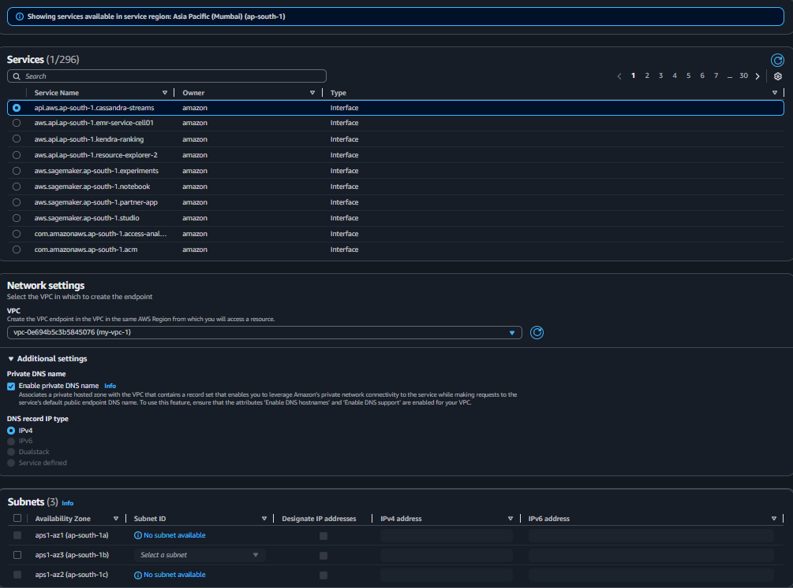

TEST PRIVATE S3 ACCESS FROM EC2
